Comparator with overflow and NMR logic

# Top level

The top level hardware block that performs the comparison is the **CFPU**. It has three bus interfaces that are described in Table 1:

Table - CFPU bus interfaces

|  |  |  |
| --- | --- | --- |
| Name | Type | Description |
| **csr** | Avalon Slave | * Program internal registers of the **CFPU** through writes * Provide task success and failure information through reads |
| **fprint** | Avalon Slave | * Takes task start and finish strobes and fingerprints from all the secondary cores through writes. No read interface |
| **oflow** | Avalon Master | * Sends directory overflow and underflow interrupts to each physical core |

The CFPU consists of 5 submodules shown in Figure 1.

* **comparator**
* **comp_registers**
* **oflow_registers**
* **fprint_registers**
* **csr_registers**

# 

Figure - Block level diagram of the CFPU

## csr_registers

This module controls the **csr** bus interface. It also contains all the programmable registers of the **CFPU**, and relays the information to the other submodules via internal signals.

The description of the **csr** bus signals regarding the registers that can be accessed are listed in Table 2.

Table - Registers in csr_registers

|  |  |  |  |  |
| --- | --- | --- | --- | --- |
| Name | Type | Address | Databits | Description |
| Core Allocation Table | Write | 0x50000D0 | writedata(25:24) = Logical ID  writedata(19:16) = Task ID  writedata(3:0) = Core ID | This is a 16x3 slot SRAM of 4bits in each space. Indexed by Task ID and Logical ID, and the memory content is the core ID |
| Directory Start Pointer | Write | 0x5000040 | writedata(25:24) = Logical ID  writedata(19:16) = Task ID  writedata(9:0) = Pointer data | This is a 16x3 slot SRAM, indexed by Task ID and Logical ID, and the memory content is the directory start pointer. |
| Directory End Pointer | Write | 0x5000080 | writedata(25:24) = Logical ID  writedata(19:16) = Task ID  writedata(9:0) = Pointer data | This is a 16x3 slot SRAM, indexed by Task ID and Logical ID, and the memory content is the directory end pointer. |
| Max Count Register | Write | 0x50000CC | writedata(25:24) = Logical ID  writedata(19:16) = Task ID  writedata(9:0) = Max Count | This is a 16x3 slot SRAM, indexed by Task ID and Logical ID, and the memory content is the maximum fingerprint count. |
| NMR register | Write | 0x50000D8 | writedata(19:16) = Task ID  writedata(0) = NMR info | This is a 16 bit register indexed by Task ID. The corresponding bit is set high when TMR is activated for the task |
| Exception Register | Read/Write | 0x50000C0 | writedata(:) | This register contains the interrupt bit for task completion/failure. The write is to reset the interrupt |
| Success Register | Read | 0x50000C4 | - | 16 bit register. If a task completes successfully, the corresponding bit is set high |
| Fail Register | Read | 0x50000C8 | - | 32 bit register. If a task fails, the corresponding two bits contain the failing Logical ID. Default value is all 1’s |

This signals between this module and the rest of the modules and their description is listed in Table 3.

Table - Signals from csr_registers to other submodules

|  |  |
| --- | --- |
| Module | Signal and Description |
| comp_registers | * *csr_task_id* – the Task ID for which the pointer is being written * *csr_logical_core_id* – the Logical ID for which the pointer is being written * *csr_start_pointer_write* – a write signal for the start pointer data from **csr_registers** to **comp_registers** * *csr_end_pointer_write* – a write signal for the end pointer data from **csr_registers** to **comp_registers** * *csr_pointer_data* – the start/end pointer data * *comp_pointer_ack* – an acknowledge of the write signal from **comp_registers** to **csr_registers** |
| fprint_registers | * *fprint_task_id* – the four bit Task ID which the incoming fingerprint (on the fprint bus) belongs to * *fprint_physical_core_id­* – The four bit core id of the core that is sending the fingerprint * *fprint_logical_core_*id – the two bit logical core id from the Core Allocation Table corresponding to the above task id and core id * *fprint_nmr* – one bit wire that is asserted when TMR is active for the Task ID in ‘*fprint_task_id*’ |
| comparator | * *comparator_status_write* – write signal from **comparator** to indicate task completion or failure * *comparator_task* – the four bit task id that the comparator is writing the status for * *comparator_logical_core_id* – the Logical ID of the failing core * *comparator_mismatch_detected* – this wire is ‘high’ is a mismatch in fingerprints has been detected * *csr_status ack* –pulse sent by **csr_registers** to acknowledge status write * *comparator_nmr* – one bit wire that is asserted when TMR is active for the Task ID in ‘*comparator_task_id*’ |
| oflow_registers | * *oflow_task_id* – The four bit Task ID of the overflowing/underflowing task * *oflow_logical_core_id* – The two bit Logical ID needed to get the corresponding Physical ID * *oflow_physical_core_ID* – the four bit Physical core id from the Core Allocation Table corresponding to the above Task ID and Logical ID * *csr_fprint_maxcount* – The maxcount value corresponding to the above Task ID and Logical ID * *oflow_nmr* – one bit wire that is asserted when TMR is active for the Task ID in ‘*oflow_task_id*’ |

## comp_registers

This submodule is in charge of keeping track of the head and tail pointers of the fingerprint directory for each task. It stores the start and end directory locations from **csr_registers** for each Logical core for each task, and includes wrap around logic for both the head and tail pointers corresponding to these values. The functionality is handled by the FSM shown in Figure 2, and described in Table 4.

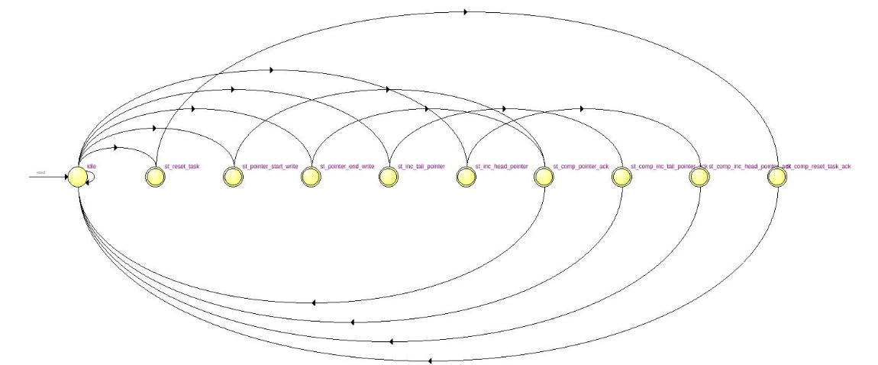

Figure - comp_registers FSM

Table - comp_registers FSM description

|  |  |
| --- | --- |
| State | Description |
| idle | If **csr_registers** sends a write start pointer signal, go to ‘st_pointer_start_write. Else ff **csr_registers** sends a write end pointer signal, go to ‘st_pointer_end_write. Else if **fprint_registers** sends an increase head pointer signal, go to ‘st_inc_head_pointer’. Else if **comparator** sends an increase tail pointer signal, go to ‘st_inc_tail_pointer’. Else if **comparator** sends a reset task signal, go to ‘st_reset_task’. Otherwise stay in ‘idle’ |
| st_pointer_start_write | Store the start pointer information, go to ‘st_comp_pointer_ack’ |
| st_pointer_end_write | Store the end pointer information, go to ‘st_comp_pointer_ack’ |
| st_comp_pointer_ack | Send an acknowledge pulse to **csr_registers**, and go to ‘idle’ |
| st_inc_head_pointer | Increment the head pointer, go to ‘st_comp_inc_head_pointer_ack’ |
| st_comp_inc_head_pointer_ack | Send an acknowledge pulse to **fprint_registers**, and go to ‘idle’ |
| st_inc_tail_pointer | Increment the tail pointer, go to ‘st_comp_inc_tail_pointer_ack’ |
| st_comp_inc_tail_pointer_ack | Send an acknowledge pulse to **comparator**, and go to ‘idle’ |
| st_reset_task | Reset the head and tail pointers to initial values corresponding to the **comparator** Task ID, and go to ‘st_comp_reset_task_ack’ |
| st_comp_reset_task_ack | Send an acknowledge pulse to **comparator**, and go to ‘idle’ |

## fprint_registers

This submodule controls the **fprint** bus interface. All writes on the bus are first stored in an internal FIFO to minimize time spent on the bus and to achieve parallelism.

When a fingerprinting task begins or ends on a core, it must notify the **CFPU**. This is done by means of a checkout and checkin register. They are each a 16x3 slot register, with one bit at each entry, and indexed by Task ID and Logical core ID. When a task begins on a logical core, the corresponding bit in the checkout register is asserted, and when a task completes on a core, the corresponding bit in the checkin register is asserted.

The processing of fingerprints and internal registers are handled by the FSM shown in Figure 3, and described in Table 5. TMR is achieved using a logical AND with the NMR bit from **csr_registers** to determine whether signals from the third logical core should be considered or not.

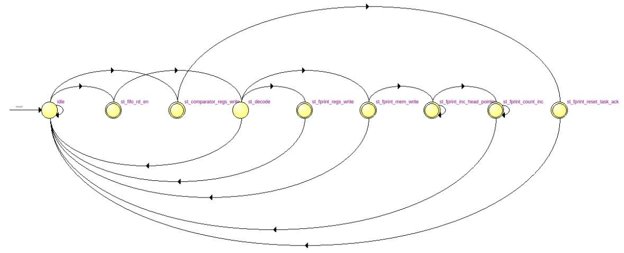

Figure - fprint_registers FSM

Table - fprint_registers FSM description

|  |  |
| --- | --- |
| State | Description |
| idle | If the comparator sends a reset task signal, go to ‘st_comparator_regs_write’. Otherwise if the **fprint** bus FIFO is not empty, go to ‘st_fifo_rd_en’. Otherwise stay in ‘idle’ |
| st_comparator_regs_write | Reset all the checkin and checkout register bits for both cores corresponding to **comparator** Task ID, go to ‘st_fprint_reset_task_ack’ |
| st_fprint_reset_task_ack | Send an acknowledge signal to **comparator** and return to ‘idle’ |
| st_fifo_rd_en | One clock cycle to get FIFO contents. Go to ‘st_decode’ |
| st_decode | If the write is for the checkout or checkin registers, go to ‘st_fprint_regs_write’, otherwise check if the core sending the fingerprint has checked out. If yes, go to ‘st_fprint_mem_write’, otherwise go to ‘idle’ |
| st_fprint_regs_write | Set the checkout/checkin register, go to ‘idle’ |
| st_fprint_mem_write | Store the fingerprint at the appropriate location in the directory. Since the fingerprints arrive in two halves, if it is the first half then go to ‘idle’, but if it is the second half then go to ‘st_fprint_inc_head_pointer’ |
| st_fprint_inc_head_pointer | Send a signal to **comp_registers** to increase the directory head pointer. Wait for an acknowledge signal, and then go to ‘st_fprint_count_inc’ |
| st_fprint_count_inc | Send a signal to **oflow_registers** to increase the fingerprint count. Wait for an acknowledge signal, and then go to ‘idle’ |

The fingerprints are stored in an internal dual port SRAM directory that is controlled by head pointer and tail pointer signals from **comp_registers**. New fingerprints are written at the location corresponding to the head pointer, and **fprint_regsiters** outputs the fingerprints at the tail pointer location for the comparator to compare.

## oflow_registers

This submodule controls the **oflow** bus interface. It keeps track of the fingerprint count for each logical core, and sends an interrupt to the corresponding core when its fingerprint count has exceeded the maximum count as dictated by the programmed value in **csr_ragisters**.

This submodule contains three 16 bit overflow status registers (one for each logical core) that asserts a corresponding bit when a task has overflowed. An *overflow* occurs when a logical core exceeds its max count. At this point, the appropriate bit in the overflow status register is asserted. An *underflow* occurs when the fingerprint count for all cores of an overflowing task (any overflow status reg bit = 1) goes down to 0.

There is an output FIFO to track *overflow* and *underflow* events. When an *overflow* occurs, the Task ID and Core ID are written directly to the FIFO. When an *underflow* occurs, submodule loops through all logical cores, and writes its information to the FIFO if the overflow status bit for that core was asserted.

This submodule also contains fprint ready and fprint remaining registers that are sent to the **comparator**. These signals were handled by **comp_registers** in the previous design, and are now being handled by this submodule due to changes in the directory access structure.

The functionality is achieved by the FSM shown in Figure 4, and described in Table 6. TMR is achieved using a logical AND with the NMR bit from **csr_registers** to determine whether signals from the third logical core should be considered or not.

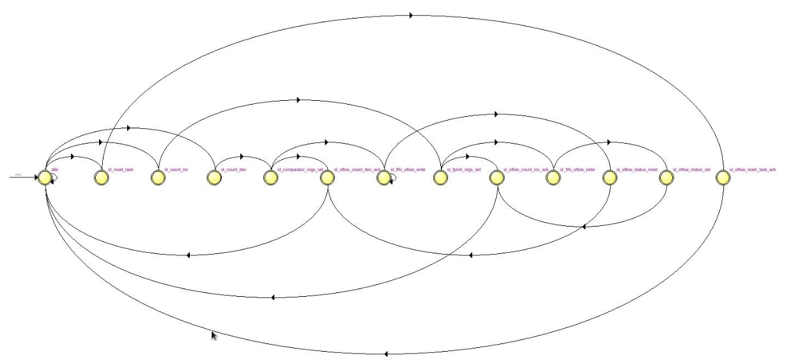

Figure - oflow_registers FSM

Table - oflow_registers FSM description

|  |  |
| --- | --- |
| State | Description |
| idle | If **comparator** sends a reset task signal, go to ‘st_reset_task’. Else if **fprint_registers** sends a count increase signal, go to ‘st_count_inc’. Else if **comparator** sends a count decrease signal, go to ‘st_count_dec’. Otherwise stay in idle |
| st_count_inc | Increase the fingerprint count, go to ‘st_fprint_regs_set’ |
| st_count_dec | Decrease the fingerprint count, go to ‘st_comparator_regs_set’ |
| st_fprint_regs_set | Update the fprint ready and remaining registers. If an *overflow* has occurred, go to ‘st_fifo_oflow_write’, else go to ‘st_oflow_count_inc_ack’ |
| st_comparator_regs_set | Update the fprint ready and remaining registers. If an *underflow* has occurred, go to ‘st_fifo_uflow_write’, else go to ‘st_oflow_count_dec_ack’ |
| st_fifo_oflow_write | Write the overflow information to the output FIFO, go to ‘st_oflow_status_set’ |
| st_fifo_uflow_write | Write the underflow information to the output FIFO, go to ‘st_oflow_status_reset’ |
| st_oflow_status_set | Set the appropriate overflow status register, go to ‘st_oflow_count_inc_ack’ |
| st_oflow_status_reset | Reset all overflow status registers for the task, go to ‘st_oflow_count_dec_ack’ |
| st_oflow_count_inc_ack | Send an acknowledge signal to **fprint_registers** and return to ‘idle’ |
| st_oflow_count_dec_ack | Send an acknowledge signal to **comparator** and return to ‘idle’ |
| st_reset_task | Reset all counts and internal registers, go to ‘st_oflow_reset_task_ack’ |
| st_oflow_reset_task_ack | Send an acknowledge signal to **comparator** and return to ‘idle’ |

## comparator

This submodule is responsible for comparing fingerprints and writing the task completion/failure status to **csr_registers**. It now receives its fprint ready and fprint remaining signals from **oflow_registers**. It still receives a checkin signal for all tasks from **fprint_registers** that has the appropriate bit asserted when all cores for the task have checked in.

The FSM that implements this submodule is described in Table 7. TMR is achieved using a logical AND with the NMR bit from **csr_registers** to determine whether signals from the third logical core should be considered or not.

Table - comparator FSM description

|  |  |
| --- | --- |
| State | Description |
| idle | If fprints are ready or task has checked in go to ‘st_set_task’, otherwise stay in ‘init’ |
| st_set_task | Latch the Task ID of the ready/checked-in task, go to ‘l st_load_pointer’ |
| st_load_pointer | One clock cycle to fetch the tail pointer from **comp_registers**, go to ‘st_load_fprint’ |
| st_load_fprint | One clock cycle to fetch the fingerprints from **fprint_registers**, go to ‘st_check_task_status’ |
| st_check_task_status | If fingerprints are ready, go to ‘compare_fprints’, else if task has checked in then if fingerprints are remaining go to ‘st_comparator_mismatch_detected’ else go to ‘st_fprint_reset_task’ |
| st_compare_fprints | If the fingerprints match then go to ‘st_comparator_inc_tail_pointer’, otherwise go to ‘st_comparator_mismatch detected’. |
| st_comparator_inc_tail_pointer | Send the inc tail pointer signal to **comp_registers** and wait for the acknowledge signal. Then go to ‘st_comparator_count_dec’ |
| st_comparator_count_dec | Send the count dec signal to **oflow_registers** and wait for the acknowledge signal. Then go to ‘st_check_task_status’ |
| st_comparator_mismatch_detected | Assert and latch the mismatch detected signal (will be reset when the state goes to ‘idle’) and go to ‘st_fprint_reset_task’ |
| st_fprint_reset_task | Send the reset signal to **fprint_registers** and wait for the acknowledge signal. Then go to ‘st_comp_reset_task’ |
| st_comp_reset_task | Send the reset signal to **comp_registers** and wait for the acknowledge signal. Then if a mismatch has been detected go to ‘st_oflow_reset_task’ else go to ‘st_comparator_status_write’ |
| st_oflow_reset_task | Send the reset signal to **oflow_registers** and wait for the acknowledge signal. Then go to ‘st_comparator_status_write’ |
| st_comparator_status_write | Assert the write status signals to **csr_registers**, and wait for the acknowledge signal. Then, go to ‘idle’ |

# Changes to be made/Future Plans

* TMR logic needs modification: Right now, there is no voting taking place and the task fails in TMR mode as soon as any one of the core fails. One way to implement voting is to duplicate the NMR register for all three logical cores. Then TMR will imply all three NMR reg bits are set. Now if there is a failure in a single core, then the NMR bit of the failing core is reset and the task continues with two cores until it completes or another fails.
* Too much bus interference, hence switching to new design where each task stores only one fingerprint (infinite block size)
* This implies no more directory pointers and hence no more **comp_resigters**
* Send checkpoint interrupts to each core on a task when they have all completed the task
* Include a task success count register, so that the monitor will be informed only when a task has completed a programmed number of times, and thus implement software checkpointing.